London Borough of Harrow Pension Fund
Annual Report and Financial Statements for the year ended 31 March 2015


CONTENTS

1. Introduction 3

2. Independent Auditor's Statement 4

3. Scheme Management and Advisors 5

4. Scheme Overview 6

5. Governance Arrangements 9

6. Investment Policy and Performance 10

7. Statements and Publications 13

8. Risk Management 14

9. Contacts 16

10. Statement of Responsibilities for the Financial Statements 17

11. Harrow Pension Fund Financial Statements 18

12. Notes to Harrow Pension Fund Financial Statements 20

13. Statement of the Consulting Actuary 45

Appendices

Appendix 1 Governance Compliance Statement
Appendix 2 Communications Policy Statement
Appendix 3 A Brief Guide to the Local Government Pension Scheme
Appendix 4 Statement of Investment Principles
Appendix 5 Funding Strategy Statement
INTRODUCTION

The main purpose of the Pension Fund Annual Report is to account for the income, expenditure and net assets of the London Borough of Harrow Pension Fund (‘the Fund’) for the financial year to 31 March 2015. This Report also explains the administration and management of the Fund, the investment and funding policy objectives and asset allocation, as well as highlighting market and Fund performance.

Information about the economic resources controlled by the Fund is provided by the net assets statement. The actuarial funding level is reported in Note 16 and in the Statement of the Consulting Actuary on page 45.

The Pension Fund Committee is responsible for overseeing the management, administration and strategic direction of the Fund. The Committee continuously reviews the Fund’s investment strategy to improve returns within acceptable risk parameters. This in turn minimises the amount the Council and other employers will need to make in contributions to the Fund to meet future liabilities.

During 2014-15, overall, equity markets continued to perform strongly with overseas markets producing returns approaching 20% in local currency and the UK 6.6%. All other asset classes in which the Fund is invested produced positive returns

The net assets of the Fund as at 31 March 2015 were £674.8m compared to £590.80m as at 31 March 2014. The Fund was ranked 14th in the local authority annual league table of investment returns for the year.



Dawn Calvert - CPFA
Director of Finance
24 September 2015

INDEPENDENT AUDITOR’S STATEMENT TO THE MEMBERS OF LONDON BOROUGH OF HARROW ON THE PENSION FUND FINANCIAL STATEMENTS

We have examined the pension fund financial statements for the year ended 31 March 2015, which comprise the Fund Account, the Net Assets Statement and the related notes 1 to 23.
This report is made solely to the members of London Borough of Harrow, as a body, in accordance with Part II of the Audit Commission Act 1998 and for no other purpose, as set out in paragraph 48 of the Statement of Responsibilities of Auditors and of Audited Bodies prepared by the Audit Commission. Our audit work has been undertaken so that we might state to the Authority those matters we are required to state to them in an auditors’ report and for no other purpose. To the fullest extent permitted by law, we do not accept or assume responsibility to anyone other than the Authority, as a body, for our audit work, for this report, or for the opinions we have formed.
Respective responsibilities of the Director of Finance and Assurance and the auditor
As explained more fully in the Statement of the Director of Finance and Assurance’s Responsibilities, the Director of Finance and Assurance is responsible for the preparation of the pension fund’s financial statements in accordance with applicable United Kingdom law.
Our responsibility is to report to you our opinion on the consistency of the pension fund financial statements within the pension fund annual report with the pension fund financial statements in the statement of accounts of London Borough of Harrow, and its compliance with applicable law and the CIPFA/LASAAC Code of Practice on Local Authority Accounting in the United Kingdom 2014/15.
We also read the other information contained in the pension fund annual report as described in the contents section and consider the implications for our report if we become aware of any apparent misstatements or material inconsistencies with the pension fund financial statements.
We conducted our work in accordance with guidance issued by the Audit Commission. Our report on the administering authority’s full annual statement of accounts describes the basis of our opinion on those financial statements.
Opinion
In our opinion, the pension fund financial statements are consistent with the full annual statement of accounts of London Borough of Harrow for the year ended 31 March 2015 and comply with applicable law and the CIPFA/LASAAC Code of Practice on Local Authority Accounting in the United Kingdom 2014/15.

Paul Schofield (Engagement Lead)
For and on behalf of Deloitte LLP
Cambridge, UK

24 September 2015

SCHEME MANAGEMENT AND ADVISORS

Administering Authority | London Borough of Harrow
Pension Fund Committee  Independent Advisors | Councillor Keith Ferry (Chairman)  Councillor Bharat Thakker(Vice Chairman)  Councillor Adam Swersky  Councillor Barry Macleod-Cullinane  Colin Robertson  Richard Romain
Co-optee  Trade Union Observers | Howard Bluston  John Royle - UNISON  Pamela Belgrave - GMB
Officer | Simon George, Director of Finance and Assurance
Actuary | Hymans Robertson LLP
Investment Consultant | Aon Hewitt Limited
Investment Managers | Aviva Investors Global Services Limited  BlackRock Investment Management (UK) Limited  GMO LLC  Insight Investment  Longview Partners  Oldfield Partners  Pantheon Ventures  Record Currency Management Limited  Standard Life Investments  State Street Global Advisors Limited
AVC Providers | Clerical Medical  Equitable Life Assurance Society  Prudential Assurance
Custodians | JP Morgan, Northern Trust, Brown Brothers Harriman &  Bank of New York Mellon
Auditor | Deloitte LLP
Performance Measurement | State Street Global Services
Bankers | The Royal Bank of Scotland

SCHEME OVERVIEW
The Harrow Pension Fund (‘the Fund’) is part of the Local Government Pension Scheme (“LGPS”) and is administered by the London Borough of Harrow. The Council is the reporting entity for the Fund.

- General
The Scheme is governed by the Public Service Pensions Act 2013.
The Fund is administered in accordance with the following secondary legislation:
- The Local Government Pension Scheme Regulations 2013 (as amended)
- The Local Government Pension Scheme (Transitional Provisions, Savings and Amendment) Regulations 2014 (as amended)
- The Local Government Pension Scheme (Management and Investment of Funds) Regulations 2009.

It is a contributory defined benefit pension scheme designed to provide pensions and other benefits for pensionable employees of the Council and a range of other scheduled and admitted bodies. Teachers, police officers and firefighters are not included as they come within other national pension schemes.

The Fund is overseen by the Harrow Pension Fund Committee, which is a committee of the Council.

- Memberships

Membership of the LGPS is voluntary and employees are free to choose whether to join the Scheme, remain in the Scheme or make their own personal arrangements outside the Scheme.

Organisations participating in the Fund are:

- Scheduled Employer: These are statutorily defined bodies listed within the LGPS Regulations and have a statutory obligation to participate in the LGPS (e.g. a local authority, a further or higher education establishment).

- Community Admission Body: These are typically charities or other not-for-profit public sector bodies providing a public service which has sufficient links with the administering employer to be regarded as having a community of interest.

- Transferee Admission Body: These are typically private sector companies or charities which will have taken on staff from a local authority as a result of an outsourcing of services.

There are 29 employer organisations within the Harrow Pension Fund including the Council itself, as detailed below.
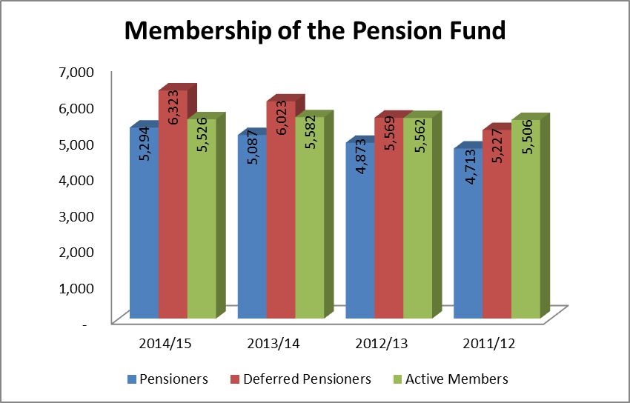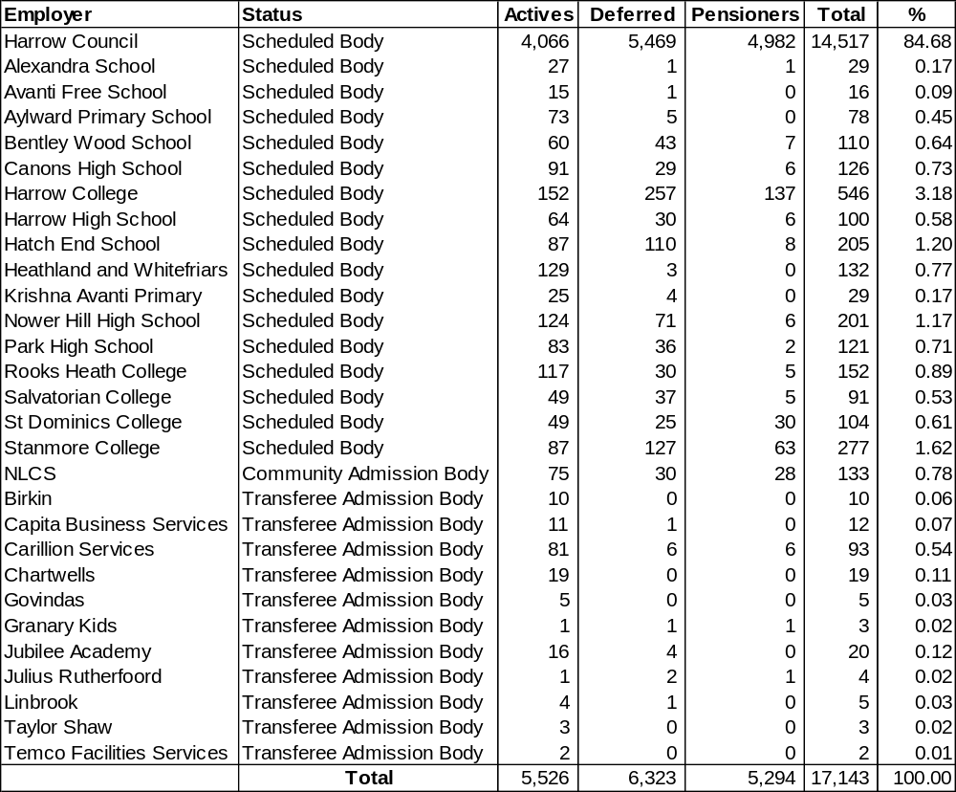

c) Funding

Membership of the Fund is voluntary. Full-time, part-time and casual employees, where there is a mutuality of obligation and who have a contract of more than three months, are brought into the Fund automatically but have the right to “opt out” if they so wish. Casual employees with no mutuality of obligation are not eligible for membership.

Employee contribution rates are set by regulations and are dependent upon each member’s full time equivalent salary. Employee contributions attract tax relief at the time they are deducted from pay and the employee also pays lower National Insurance contributions between the Lower and Upper Earnings Limits, unless the employee has opted to pay the married woman’s reduced rate.

Employers participating in the Fund pay different rates of contributions depending on their history, their staff profile and any deficit recovery period agreed with the Fund. Employer contribution rates are reviewed as part of the triennial actuarial valuation. The last valuation took place as at 31 March 2013 and showed that the Fund was 70% Funded. The deficit is to be funded by additional employer contributions over the course of 20 years.

Benefits are funded by contributions and investment earnings. Contributions are made by active members of the Fund in accordance with the LGPS Regulations 2013 and range from 5.5% to 12.5% of pensionable pay. Employee contributions are matched by employers’ contributions which are set based on triennial actuarial funding valuations. Currently almost all, employer contribution rates fall within the range 15% to 28% of pensionable pay with most of the largest employers paying 19.85%.

d) Benefits
Prior to 1 April 2014, pension benefits under the LGPS were based on final pensionable pay and length of pensionable service, summarised below.

 | Service pre 1 April 2008 | Service post 31 March 2008
Pension | Each year worked is worth 1/80 x final pensionable salary | Each year worked is worth 1/60 x final pensionable salary
Lump Sum | Automatic lump sum of 3 x salary. In addition, part of the annual pension can be exchanged for a one-off tax-free cash payment. A lump sum of £12 is paid for each £1 of pension given up | No automatic lump sum. Part of the annual pension can be exchanged for a one-off tax-free cash payment. A lump sum of £12 is paid for each £1 of pension given up

From 1 April 2014, the Scheme became a career average scheme, whereby members accrue benefits based on their pensionable pay in each year at an accrual rate of 1/49th. Accrued pension is updated annually in line with the Consumer Prices Index.

There are a range of other benefits provided under the Scheme including early retirement, disability pensions and death benefits. For more details, please refer to the ‘Brief Guide to the Local Government Pension Scheme’ attached as Appendix 3.

GOVERNANCE ARRANGEMENTS

The Council has delegated to the Pension Fund Committee various powers and duties in respect of its administration of the Fund. The Committee met four times during the year .It comprises four Councillors with full voting rights. Representatives from the trade unions are able to participate as members of the Committee but do not have voting rights.

The Pension Fund Committee has the following terms of reference:
- to exercise on behalf of the Council, all the powers and duties of the Council in relation to its functions as Administering Authority of the LB Harrow Pension Fund (the Fund), save for those matters delegated to other Committees of the Council or to an Officer;
- the determination of applications under the Local Government Superannuation Regulations and the Teachers’ Superannuation Regulations;
- to administer all matters concerning the Council’s pension investments in accordance with the law and Council policy;
- to establish a strategy for the disposition of the pension investment portfolio;
- to appoint and determine the investment managers’ delegation of powers of management of the Fund;
- to determine cases that satisfy the Early Retirement provision under Regulation 26 of the Local Government Pension Scheme Regulations 1997 (as amended), and to exercise discretion under Regulation 8 of the Local Government (Early Termination of Employment) (Discretionary Compensation) (England and Wales) Regulations 2000 (as amended), subject to the conditions now agreed in respect of all staff, excluding Chief Officers;
- to apply the arrangements set out in (6) above to Chief Officers where the application has been recommended by the Chief Executive, either on the grounds of redundancy, or in the interests of the efficiency of the service, and where the application was instigated by the Chief Executive in consultation with the leaders of the political groups.

The Committee is advised by two independent advisors, a co-optee and an Investment Consultant.
The dates of the Pension Fund Committee meetings, along with meeting agendas, reports and minutes are available on the Harrow Council website:
http://www.harrow.gov.uk/www2/mgCommitteeDetails.aspx?ID=1297

During 2014/15 arrangements were put in place for the appointment of a Local Pension Board which, from 2015/16 will assist the Council and the Pension Fund Committee in the administration of the Fund.
INVESTMENT POLICY AND PERFORMANCE

Investment Market Commentary

Equity markets performed strongly but with marked regional differences. UK equities returned only 6% for the year with investors concerned about the possibility of political uncertainty resulting from a hung Parliament post the general election. Japan was the strongest performing of the major overseas markets returning over 30% to local investors, but a slightly lower 27% to UK investors as the Yen continued to weaken against Sterling. Conversely UK investors benefited from the strength of the US Dollar over the year which represented almost half of the US equity return of 25%, Pacific and emerging markets returned 16% and 14% respectively whilst Europe returned 9% for the year.

After the near flat outcome in 2013/14, UK bonds bounced back strongly, producing double digit returns. Duration was the big story of the latest year with marked differences in return depending upon where funds were invested across the yield curve. Long dated gilts produced returns approaching 30% as yields reached historic lows. Investors needing to hold them for liability matching purposes continued to buy them at any price. On the other, hand, short dated bonds returned only 3% for the year. The index-linked story for the year was much the same; funds returning 20% on average with the return driven by longer dated issues.

Alternative investments in aggregate also enjoyed a good year. Private equity returned 16% whilst hedge funds averaged 9%. Pooled multi asset (diversified growth) investments, which have recently been gaining traction amongst funds, returned a strong 10%, well ahead of most funds’ targets for this asset class. Property returned 16% for the year.

Investment Policy

The investment objective of the Fund is to achieve a return that is sufficient to meet the primary funding objective of minimising the level of employer contribution in order to meet the cost of Fund benefits as required by statute, subject to an appropriate level of risk (implicit in the target) and liquidity.

The Council has delegated the management of the Fund’s investments to professional investment managers, appointed in accordance with the LGPS regulations, whose activities are specified in detailed investment management agreements and regularly monitored.

The Fund Statement of Investment Principles specifies that the Fund may invest in accordance with the Regulations in equities, fixed interest and other bonds and property, in the UK and overseas markets. The Regulations specify other investment instruments that may be used, for example, financial futures, traded options, insurance contracts, stock lending and sub-underwriting contracts.

To support the Fund’s objective of achieving a return that is sufficient to meet the cost of benefits and achieving this within acceptable risk parameters the Committee, in conjunction with the Fund’s investment advisor, set the strategic asset allocation on 6 March 2013.

The Committee aims to achieve its investment objective by maintaining a high allocation to growth assets, mainly equities, reflecting the security of the sponsor’s covenant, the funding level, the long time horizon of the Fund and the projected asset class returns and volatility. Diversifying investments reduces the risk of a sharp fall in one particular market having a substantial impact on the whole Fund.
During the year contracts with Fidelity, Wellington and Barings were terminated and new agreements put in place with GMO, Oldfields and Insight. The State Street mandate was changed from UK equities to global equities. The overall equity portfolio was rebalanced to implement the strategy agreed by the Committee.

The following table compares the actual asset allocation as at 31 March 2015 to the agreed allocation
Investment assets | Actual Percentage of Fund | Agreed Allocation
 | % | %
Fixed interest securities | 10 | 10
Index-linked securities | 3 | 3
Developed world equities-active | 23 | 21
Emerging markets equities-active | 11 | 10
Global equities-passive | 33 | 31
Pooled property | 8 | 10
Private equity | 3 | 5
Diversified growth funds | 9 | 10
Total | 100 | 100

The Committee believes in appointing Fund managers with clear performance benchmarks that place maximum accountability for performance against that benchmark with the investment manager. Fund managers are set risk parameters to provide them with some flexibility in achieving the asset allocation to allow them to make the most of market conditions. They must seek approval for any positions that go beyond the agreed risk parameters set for their strategies. Following the manager changes discussed above, the Fund has ten investment managers to give diversification of investment style and spread of risk. The Committee will continue to monitor the ability of the investment managers to achieve their target returns.

Investments held by Fund Managers
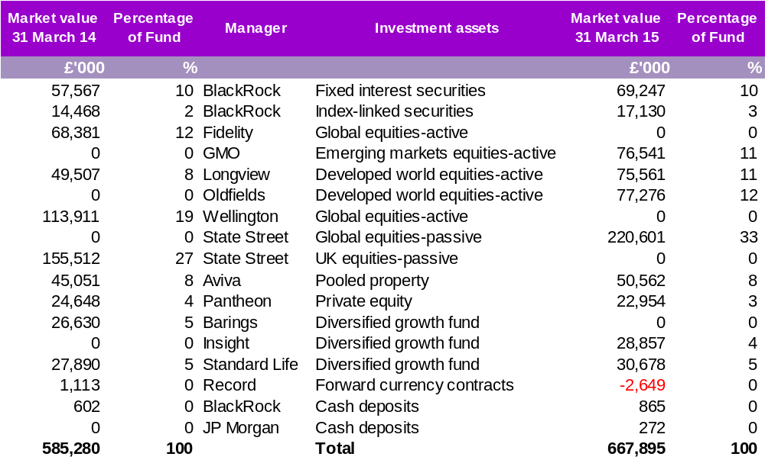

Fund performance
The Committee uses State Street Global Services as its independent investment performance measurer. Investment returns over 1, 3 and 5 years are shown below.

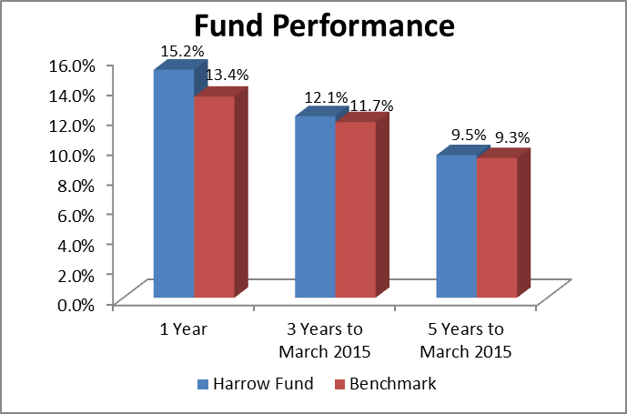

Source: State Street Global Services

The Fund’s return of 15.2% during 2014-15 was due to positive returns for all assets classes. Returns over all three time periods were strong, reflecting recovery from the significantly lower returns achieved at the height of the financial crisis in 2008.

The average local authority fund (as measured by State Street Global Services) returned 13.2% on its assets during the year. The Council’s Fund was ranked 14th (2013-14: 19th) in the local authority annual league table of investment returns for the year. This was almost entirely due to the relatively low commitment to the UK equity market and successful stock selection policies of the various fund managers.

STATEMENTS AND PUBLICATIONS

Governance Compliance Statement
The Local Government Pension Scheme (Administration) Regulations 2008 Regulation 31 require all administering authorities to produce a Governance Compliance Statement. This Statement must set out whether the Administering Authority delegates its function and if so what the terms, structure and operation of the delegation are. The Administering Authority must also state the extent to which a delegation complies with guidance given by the Secretary of State. The current Statement can be found in Appendix 1.

Communications Policy Statement
The Local Government Pension Scheme (Administration) Regulations 2008 require all administering authorities to produce a Communications Policy Statement. This statement sets out the Fund’s strategy for communicating with members, members’ representatives, prospective members and employing authorities, together with the promotion of the Scheme to prospective members and their employing authorities. The latest Statement can be found in Appendix 2.

Local Government Pension Scheme Guide
A brief guide to the Local Government Pension Scheme can be found in Appendix 3

Statement of Investment Principles
Regulation 12 of the Local Government Pension Scheme (Management and Investment of Funds) Regulations 2009 requires administering authorities to publish a Statement of Investment Principles. This Statement provides details of the Fund’s investment policies including:

• The types of investment to be held;
• The balance between different types of investment; and
• Risk measurement and management.

The Statement also details the Fund’s compliance with the six principles set out in the Chartered Institute of Public Finance and Accountancy’s publication ‘Investment Decision Making and Disclosure in the Local Government Pension Scheme 2009 – a guide to the application of the 2008 Myners Principles to the management of LGPS Funds’.
The current version can be found in Appendix 4.

Funding Strategy Statement
Regulation 35 of the Local Government Pension Scheme (Administration) Regulations 2008 requires all administering authorities to produce a Funding Strategy Statement. The purpose of the Funding Strategy Statement is to explain the funding objectives of the Fund, in particular:

• How the costs of the benefits provided under the LGPS are met through the Fund;
• The objectives in setting employer contribution rates; and
• The funding strategy that is adopted to meet these objectives.

The Funding Strategy Statement is reviewed every three years at the same time as the triennial actuarial valuation of the Fund. An interim review of the Statement may be carried out and a revised Statement published if there has been a material change in the policy matters set out in the Statement or there has been a material change to the Statement of Investment Principles. The current full Statement can be found in Appendix 5.

RISK MANAGEMENT

The Fund’s primary long term risk is that the assets will fall short of its liabilities (i.e. promised benefits payable to members). The Pension Fund Committee is responsible for managing and monitoring risks and ensuring that appropriate risk management processes are in place and operating effectively. The aim of risk management is to limit risks to those that are expected to provide opportunities to add value.

The most significant risks faced by the Fund and the procedures in place to manage these risks are described below:

Governance and Regulatory Risk

The failure to exercise good governance and operate in line with regulations can lead to financial as well as reputation risk. These risks are managed through:

  - Regular reviews of the Statement of Investment Principles and Funding Strategy Statement that set out the high level objectives of the Fund and how these will be achieved;
  - Tailored training for members;
  - Reviews of the Pension Fund Committee agenda and papers by Harrow’s Legal Department; and.
  - Establishment of the Pension Board.

- Sponsor Risk

The Fund is currently in deficit and achieving a fully funded status may require the continued payment of deficit contributions. The Actuary reviews the required level of contributions every three years. To protect the Fund and the Administering Employer, bonds and other forms of security are received from Admitted employers.

- Investment Risk

The Fund is invested in a range of asset classes as detailed in Note 13. This is done in line with the Local Government Pension Scheme (Management and Investment of Funds) Regulations 2009 which require pension funds to invest any monies not immediately required to pay benefits. These Regulations require the formulation of a Statement of Investment Principles which sets out the Fund’s approach to investment including the management of risk. The predominant asset class is listed equities, which has both a greater expected return and volatility than the other main asset classes. Potential risks affecting investments include:

Pricing Risk
The valuation of investments is constantly changing, impacting on the potential realisation proceeds and income. For example, the value of the Fund’s investments increased by 14% in 2014-15 compared to 11% for the previous year. Most of the price changes relate to the value of global equities. Changes of a similar magnitude are possible in future.

Procedures in place to manage the volatility of investments include:

  - Diversification of the investments between asset classes and geographical areas to include fixed interest and index linked bonds, property, multi assets mandates and private equity. The investment strategy is reviewed by the Pension Fund Committee and market conditions are reviewed to monitor performance at every meeting to determine if any strategic action is required;
  - Global equities are managed by three active managers and diversified growth funds by two managers to reduce the risk of underperformance against benchmarks. The Investment Advisor provides quarterly reports on the performance and skills of each manager to the Pension Fund Committee; and
  - The benefit liabilities are all Sterling based and to reduce the currency risk from non Sterling investments, 50% of the overseas currency exposures are hedged to Sterling.

Liquidity Risk
Investments in some asset classes e.g. private equity and property can be illiquid in that they cannot be realised at short notice. Around 11% of Harrow’s Fund is in illiquid assets. This is deemed appropriate for a fund that continues to have a positive cashflow. All cash balances are managed in accordance with the Council’s Treasury Management Strategy Statement and are all currently on overnight deposit and readily accessible.

Counterparty Risk
The failure by a counterparty, including an investee company, can lead to an investment loss. This risk is mainly managed through wide diversification of counterparties and also through detailed selection of counterparties by external fund managers.

- Actuarial Risk

The value of the liability for future benefits is impacted by changes in inflation, salary levels, life expectancy and expected future investment returns. Although there are opportunities to use financial market instruments to manage some of these risks, the Pension Fund Committee does not currently believe these to be appropriate. Recent changes to the benefits structure will reduce some of these risks. All are monitored through the actuarial valuation process and additional contributions required from employers should deficits arise.

- Operational Risk

Operational risk relates to losses (including error and fraud) from failures in internal controls relating to investment managers and internally e.g. administration systems.

Controls at external fund managers are monitored through the receipt of audited annual accounts for each manager together with annual assessments of the control environment including reviews of internal controls reports certified by reporting accountants.

Controls within the Administering Authority are reviewed by Harrow’s Internal Audit Team.

CONTACTS

Registered Address | London Borough of Harrow  Shared Services - Pensions,  3rd Floor South Wing,  Civic Centre,  Harrow,  HA1 2XF
Administration Enquiries | Email address: Pension@harrow.gov.uk  Telephone Number: 020 8424 1186  Website: www.harrowpensionfund.org
Complaints and Advice | The Pensions Advisory Service  11 Belgrave Road  London  SW1V 1RB  Telephone Number: 0300 123 1047  Website: www.pensionsadvisoryservice.org.uk  The Pensions Regulator  Napier House  Trafalgar Place  Brighton  BN1 4DW  Telephone Number: 0870 6063636  Website: www.thepensionsregulator.gov.uk  The Pensions Ombudsman  11 Belgrave Road  London  SW1V 1RB  Telephone Number: 0207 630 2200  Fax Number: 0207 821 0065  Email: enquiries@pensions-ombudsman.org.uk  Website: www.pensions-ombudsman.org.uk
Tracing Service | The Pension Tracing Service  Tyneview Park  Whitley Road  Newcastle Upon Tyne  NE98 1BA  Telephone Number: 0845 6002 537  Website: www.gov.uk/find-lost-pension

STATEMENT OF RESPONSIBILITIES FOR THE FINANCIAL STATEMENTS

The Council’s Responsibilities

The Council is required:

- To make arrangements for the proper administration of its financial affairs and to secure that one of its officers has the responsibility for the administration of those affairs. In Harrow, that officer is the Chief Financial Officer, i.e., the Director of Finance;

- To manage its affairs to secure economic, efficient and effective use of resources and safeguard its assets; and

- To approve the Financial Statements.

The Director of Finance’s Responsibilities

The Director of Finance is responsible for the preparation of the Fund’s Statement of Accounts in accordance with proper practices set out in the CIPFA Code of Practice on Local Authority Accounting.

In preparing this Statement of Accounts, the Director of Finance has:

- Selected suitable accounting policies and then applied them consistently;

- Made judgements and estimates that were reasonable and prudent;

- Complied with the Code of Practice on Local Authority Accounting;

- Kept proper accounting records which were up to date; and

- Taken reasonable steps for the prevention and detection of fraud and other irregularities.

I certify that these Financial Statements present fairly the financial position of the London Borough of Harrow Fund of the Local Government Pension Scheme as at 31 March 2015 and its income and expenditure for the year then ended.

Dawn Calvert – CPFA
Director of Finance
24 September 2015
Harrow Pension Fund Account for
the year ended 31 March 2015

2013/14 |  | Notes | 2014/15
£'000 |  |  | £'000
 | Dealings with members, employers and others directly involved in the fund
-25,458 | Contributions | 6 | -28,013
-2,874 | Individual transfers in from other pension funds | 7 | -1,267
-306 | Other income |  | -35
-28,638 |  |  | -29,315
31,259 | Benefits | 8 | 32,008
1,074 | Payments to and on account of leavers | 9 | 2,266
32,333 |  |  | 34,274
3,695 | Net additions/reductions from dealings with members |  | 4,959
820 | Management expenses | 10 | 1,095
 | Return on investments
-7,468 | Investment income | 11 | -10,863
-75 | Investment management expenses | 12 | 113
-35,562 | Profit/losses on disposal of investments and changes in the market value of investments | 13A | -79,332
-43,105 | Net return on investments |  | -90,082
-38,590 | Net (increase)/decrease in the net assets available for benefits during the year |  | -84,028
-552,227 | Net Assets at start of year |  | -590,817
-590,817 | Net Assets at end of year |  | -674,845

Net Assets Statement as at
31 March 2015

31/03/2014 |  | Notes | 31/03/2015
£'000 |  |  | £'000
 | Investment assets
583,565 | Pooled investment vehicles | 13B | 669,407
1,351 | Derivative contracts | 13B | 1,459
584,916 |  |  | 670,866
 | Investment liabilities
-238 | Derivative contracts | 13B | -4,108
584,678 |  |  | 666,758
602 | Cash with investment managers |  | 1,137
585,280 |  |  | 667,895
4,271 | Cash deposits |  | 5,793
589,551 |  |  | 673,688
2,000 | Current assets | 18 | 2,051
-734 | Current liabilities | 19 | -894
590,817 | Net assets of fund available to fund benefits at the period end |  | 674,845

The accounts summarise the transactions of the Fund and deal with the net assets. The Net Assets Statement does not take account of the obligations to pay pensions and benefits which fall due after the end of the Fund year. The actuarial position of the Fund, which does take account of such obligations, is dealt with in the actuarial statement included on pages 45,46 and 47 and these Financial Statements should be read in conjunction with it.

Dawn Calvert – CPFA
Director of Finance
24 September 2015
Notes to the Harrow Pension Fund Accounts for the year ended 31 March 2015

NOTE 1: BASIS OF PREPARATION
The Statement of Accounts summarises the Fund’s transactions for the 2014/15 financial year and its position at year-end as at 31 March 2015. The accounts have been prepared in accordance with the Code of Practice on Local Authority Accounting in the United Kingdom 2014/15 which is based upon International Financial Reporting Standards (IFRS), as amended for the UK public sector.

The accounts summarise the transactions of the Fund and report on the net assets available to pay pension benefits. The accounts do not take account of obligations to pay pensions and benefits which fall due after the end of the financial year.

NOTE 2: SUMMARY OF SIGNIFICANT ACCOUNTING POLICIES
Fund account - Income
a) Contributions income
Normal contributions, both from the members and from employers, are accounted for on an accruals basis at the percentage rate recommended by the Fund actuary in the financial year to which they relate.
Employer deficit funding contributions are accounted for on the due dates on which they are payable under the schedule of contributions set by the Fund actuary or on receipt if earlier than the due date.
Employers’ augmentation contributions and pensions strain contributions are accounted for in the period in which the liability arises. Any amount due in year but unpaid will be classed as a current financial asset.
b) Transfers to and from other schemes
Transfer values represent the amounts received and paid during the year for members who have either joined or left the Fund during the financial year and are calculated in accordance with The Local Government Pension Scheme Regulations (see notes 7 and 9).

Individual transfers in/out are accounted for when received/paid, which is normally when the member liability is accepted or discharged.
Transfers in from members wishing to use the proceeds of their additional voluntary contributions to purchase Scheme benefits are accounted for on a receipts basis.
c) Investment income
- Interest income
Interest income is recognised in the Fund account as it accrues, using the effective interest rate of the financial instrument as at the date of acquisition or origination
- Distributions from pooled funds
Distributions from pooled funds are recognised at the date of issue.
- Movement in the net market value of investments
Changes in the net market value of investments are recognised as income and comprise all realised and unrealised gains/losses during the year.
Fund account – Expenditure
a) Benefits payable
Pensions and lump-sum benefits payable include all amounts known to be due as at the end of the financial year. Any amounts due but unpaid are disclosed in the net assets statement as current liabilities.
b) Taxation
The Fund is a registered public service scheme under section 1(1) of Schedule 36 of the Finance Act 2004 and as such is exempt from UK income tax on interest received and from capital gains tax on the proceeds of investments sold. Income from overseas investments suffers withholding tax in the country of origin, unless exemption is permitted. Irrecoverable tax is accounted for as a Fund expense as it arises.
c) Management expenses
The Council discloses its Pension Fund management expenses in accordance with the CIPFA guidance Accounting for Local Government Pension Scheme Management Costs.
d) Administrative expenses
All administrative expenses are accounted for on an accruals basis. All staff costs of the Pension’s Administration Team are recharged to the Fund. Associated management, accommodation and other overheads are apportioned to this activity and recharged as expenses to the Fund.
e) Oversight and governance costs
All oversight and governance expenses are accounted for on an accruals basis.
f) Investment management expenses
All investment management expenses are accounted for on an accruals basis.
Where an investment manager’s fee note has not been received by the balance sheet date, an estimate based upon the market value of their mandate as at the end of the year is used for inclusion in the Fund account. In 2014/15, £0.3m of fees is based on such estimates (2013/14: £0.1m).
The costs of the Council’s in-house Fund Management Team are recharged to the Fund and a proportion of the Council’s costs representing management time spent by officers on investment management are also charged to the Fund.
Net assets statement
a) Financial assets
Financial assets are included in the net assets statement on a fair value basis as at the reporting date. A financial asset is recognised in the net assets statement on the date the Fund becomes party to the contractual acquisition of the asset. From this date any gains or losses arising from changes in the fair value of an asset are recognised in the Fund account.
The values of investments as shown in the net assets statement have been determined as follows:
- Market-quoted investments
The value of an investment for which there is a readily available market price is determined by the bid market price ruling on the final day of the accounting period.
- Fixed interest securities
Fixed interest securities are recorded at bid market price ruling on the final day of the accounting period.
- Unquoted investments
Investments in private equity funds and unquoted listed partnerships are valued based on the Fund’s share of the net assets in the private equity fund or limited partnership using the latest financial statements published by the respective fund managers in accordance with the guidelines set out by the British Venture Capital Association. The Fund’s private equity investments are valued by the manager at 31 December 2014 and are adjusted to take into account distributions/contributions and exchange rate movements taking place up to 31 March 2015
- Pooled investment vehicles
Pooled investment vehicles are valued at closing bid price if both bid and offer prices are published; or if single priced, at the closing price available. In the case of pooled investment vehicles that are accumulation funds, change in market value also includes income which is reinvested in the Fund, net of applicable withholding tax.
b) Derivatives
The Fund uses derivative financial instruments to manage its exposure to specific risks arising from its investment activities. The Fund does not hold derivatives for speculative purposes.
Derivative contract assets are fair valued at bid prices and liabilities are fair valued at offer prices. Changes in the fair value of derivative contracts are included in change in market value.
The future value of forward currency contracts is based on market forward exchange rates at the year-end date and determined as the gain or loss that would arise if the outstanding contract were matched at the year-end with an equal and opposite contract.
c) Cash and cash equivalents
Cash comprises cash in hand and demand deposits and includes amounts held by the Fund’s external managers and custodians.
Cash equivalents are short-term, highly liquid investments that are readily convertible to known amounts of cash and that are subject to minimal risk of changes in value.
d) Financial liabilities
The Fund recognises financial liabilities at fair value as at the reporting date. A financial liability is recognised in the net assets statement on the date the Fund becomes party to the liability. From this date any gains or losses arising from changes in the fair value of the liability are recognised by the Fund.
e) Actuarial present value of promised retirement benefits
The actuarial present value of promised retirement benefits is assessed on an annual basis by the Fund actuary in accordance with the requirements of IAS 19 and relevant actuarial standards.
As permitted under the Code, the Fund has opted to disclose the actuarial present value of promised retirement benefits by way of a note to the net assets statement (Note 17).

NOTE 3: CRITICAL JUDGEMENTS IN APPLYING ACCOUNTING POLICIES
Unquoted private equity investments
It is important to recognise the subjective nature of determining the fair value of private equity investments. They are inherently based on forward-looking estimates and judgements involving many factors. Unquoted private equities are valued by the investment managers using guidelines set out by the British Venture Capital Association. The value of unquoted private equities at 31 March 2015 was £23.0m (31 March 2014 £24.6 m).
Pension Fund liability
The Pension Fund liability is calculated every three years by the appointed actuary. Annual updates in the intervening years use the methodology in line with accepted guidelines and in accordance with IAS 19. Assumptions underpinning the valuations are agreed with the actuary and are summarised in notes 16 and 17. The latter estimate is subject to significant variances based on changes to the underlying assumptions.

NOTE 4: ASSUMPTIONS MADE ABOUT THE FUTURE AND OTHER MAJOR SOURCES OF ESTIMATION UNCERTAINTY
The preparation of financial statements requires management to make judgements, estimates and assumptions that affect the amounts reported for assets and liabilities at the balance sheet date and the amounts reported for the revenues and expenses during the year. Estimates and assumptions are made taking into account historical experience, current trends and other relevant factors. However, the nature of estimation means that the actual outcomes could differ from the assumptions and estimates.
The items in the net assets statement at 31 March 2015 for which there is a significant risk of material adjustment in the forthcoming financial year are as follows;
Item | Uncertainties | Effect if actual results differ from assumptions
Actuarial present value of promised retirement benefits | Estimation of the net liability to pay pensions depends on a number of complex judgements relating to the discount rate used, the rate at which salaries are projected to increase, changes in retirement ages, mortality rates and expected returns on pension fund assets. A firm of consulting actuaries is engaged to provide the fund with expert advice about the assumptions to be applied. | The effects on the net pension liability of changes in individual assumptions can be measured. For instance, a 0.5% decrease in the discount rate assumption would result in an increase in the pension liability of £93m. A 0.5% increase in assumed earnings inflation would increase the value of liabilities by approximately £24m, a 0.5% increase in pension increase would increase the liability by approximately £67m and a one-year increase in assumed life expectancy would increase the liability by approximately £30m.
Private equity | Private equity investments are valued at fair value in accordance with British Venture Capital Association guidelines. These investments are not publicly listed and as such there is a degree of estimation involved in the valuation. | The total private equity investments in the financial statements are £23.0m. There is a risk that this investment may be under- or overstated in the accounts.

NOTE 5: EVENTS AFTER THE REPORTING DATE
These are events that occur between the end of the reporting period and the date when the financial statements are authorised for issue.

The Fund is not aware of any such events.
NOTE 6: CONTRIBUTIONS RECEIVABLE

By category

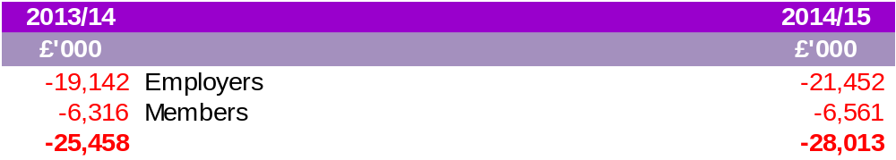

By authority

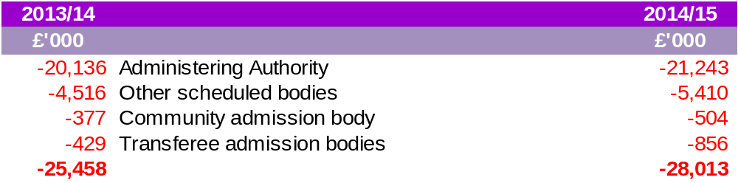

By type

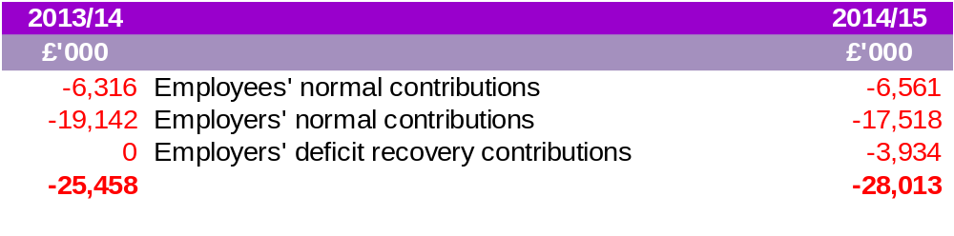
NOTE 7: TRANSFERS IN FROM OTHER PENSION FUNDS

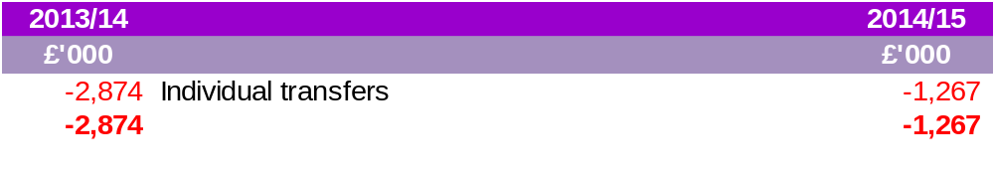

NOTE 8: BENEFITS PAYABLE

By category

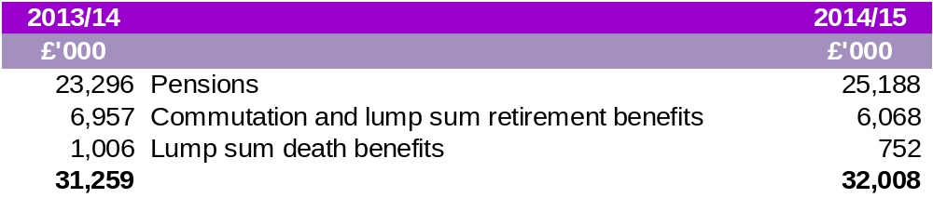

By authority

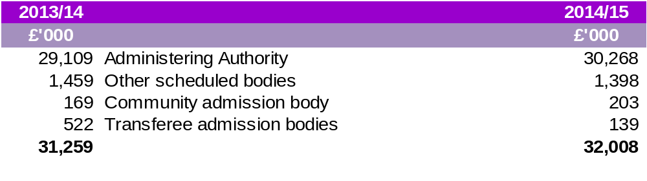
NOTE 9: PAYMENTS TO AND ON ACCOUNT OF LEAVERS

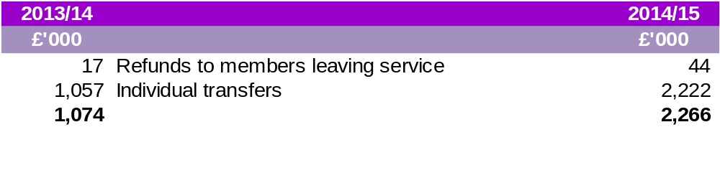
NOTE 10: MANAGEMENT EXPENSES

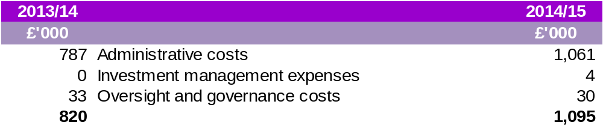
External audit fees of £21,000, the same as in the previous year, were charged.

In addition to these costs, management costs are charged direct to the investments by the Fund Managers and indirect costs are incurred through the bid-offer spread on investments sales and purchases. The latter are reflected in the cost of investment acquisitions and in the proceeds from the sales of investments (see Note 13A).

NOTE 11: INVESTMENT INCOME

2013/14 |  | 2014/15
£'000 |  | £'000
-3,100 | Private equity income | -5,723
-1,534 | Pooled property investments | -1,940
-2,772 | Pooled investments - units trusts and other managed funds | -3,200
-62 | Other | 0
-7,468 |  | -10,863

NOTE 12: INVESTMENT EXPENSES

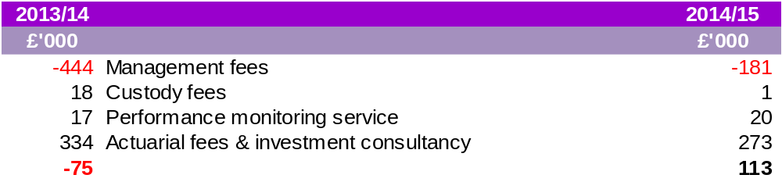
NOTE 13: INVESTMENTS

Market value 31 March 14 |  | Market value 31 March 15
£'000 |  | £'000
 | Investment assets
57,567 | Fixed interest securities | 69,247
14,468 | Index-linked securities | 17,130
387,311 | Pooled equity investments | 449,979
45,051 | Pooled property investments | 50,562
24,648 | Private equity/infrastructure | 22,954
54,520 | Alternative investments | 59,535
1,351 | Derivative contracts: forward currency | 1,459
602 | Cash deposits | 1,137
585,518 | Total investment assets | 672,003
 | Investment liabilities
-238 | Derivative contracts: forward currency | -4,108
-238 | Total investments liabilities | -4,108
585,280 | Net investment assets | 667,895

NOTE 13A: RECONCILIATION OF MOVEMENTS IN INVESTMENTS AND DERIVATIVES

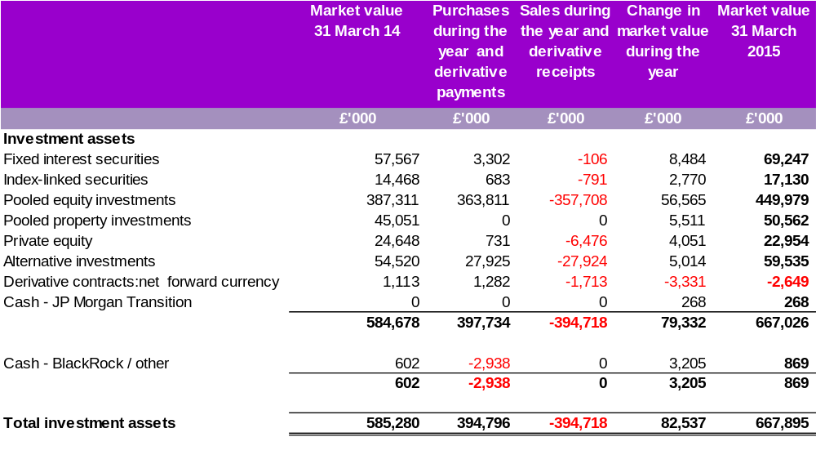
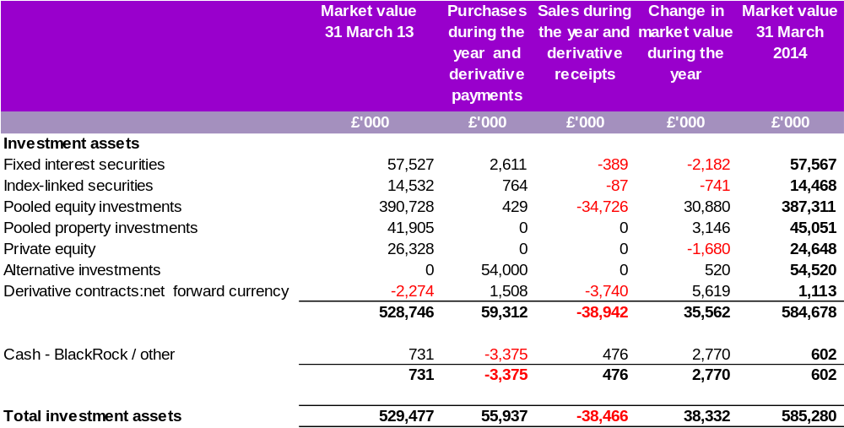
NOTE 13B: ANALYSIS OF POOLED INVESTMENTS

31 March 14 |  |  | 31 March 15
£'000 |  |  | £'000
 | UK
57,567 | Fixed Interest Securities | Corporate | 69,247
14,468 | Index Linked Securities | Public Sector | 17,130
45,051 | Managed Funds - Property | Unit Trusts | 50,562
155,512 | Managed Funds - Other | Unitised Insurance Policy | 0
272,598 |  |  | 136,939
 | Global
141,801 | Managed Funds - Other | Unit Trusts | 30,678
0 | Managed Funds - Other | Unitised Insurance Policy | 220,601
24,648 | Managed Funds - Other | Private Equity | 22,954
144,518 | Managed Funds - Other | Other | 258,235
310,967 |  |  | 532,468
583,565 |  |  | 669,407

Analysis of derivatives
Objectives and policies for holding derivatives

Most of the holding in derivatives is to hedge liabilities or hedge exposures to reduce risk in the Fund. Derivatives may be used to gain exposure to an asset more efficiently than holding the underlying asset. The use of derivatives is managed in line with the investment management agreement agreed between the Fund and the various investment managers.
In order to maintain appropriate diversification and to take advantage of overseas investment returns, a significant proportion of the Fund’s equity portfolio is in overseas stock markets. To reduce the volatility associated with fluctuating currency rates, the Fund has a passive currency programme in place managed by Record Currency Management Limited. The Fund hedges 50% of the exposure in various currencies within the equities portfolio.
Open forward currency contracts

Settlement | Currency bought | Local value | Currency sold | Local value | Asset value | liability value
 |  | 000 |  | 000 | £'000 | £'000
Up to one month | AUD | 5,591 | GBP | -2,898 |  | -20
Up to one month | CAD | 9,073 | GBP | -4,843 |  | -16
Up to one month | CHF | 6,888 | GBP | -4,825 |  | -44
Up to one month | EUR | 6,495 | GBP | -4,753 |  | -53
Up to one month | GBP | 4,495 | CHF | -6,888 |  | -286
Up to one month | GBP | 3,763 | HKD | -45,284 |  | -172
Up to one month | GBP | 5,795 | JPY | -1,070,200 |  | -219
Up to one month | GBP | 207 | SGD | -426 |  | -2
Up to one month | GBP | 23,512 | USD | -37,552 |  | -1,788
Up to one month | HKD | 15,098 | GBP | -1,312 |  | -0
Up to one month | JPY | 1,832,800 | GBP | -10,338 |  | -39
Up to one month | NOK | 13,708 | GBP | -1,178 |  | -31
Up to one month | SEK | 4,555 | GBP | -376 |  | -20
One to six months | GBP | 9,925 | JPY | -1,832,800 |  | -394
One to six months | GBP | 23,379 | USD | -36,181 |  | -1,013
Over six months | GBP | 24,392 | USD | -36,181 |  | -11
Up to one month | GBP | 2,929 | AUD | -5,591 | 51
Up to one month | GBP | 5,025 | CAD | -9,073 | 198
Up to one month | GBP | 5,090 | EUR | -6,495 | 389
Up to one month | GBP | 4,309 | JPY | -762,600 | 24
Up to one month | GBP | 1,185 | NOK | -13,708 | 39
Up to one month | GBP | 375 | SEK | -4,555 | 19
Up to one month | HKD | 30,186 | GBP | -2,531 | 92
Up to one month | SGD | 426 | GBP | -208 | 1
Up to one month | USD | 37,552 | GBP | -25,216 | 85
One to six months | GBP | 2,885 | AUD | -5,591 | 20
One to six months | GBP | 4,840 | CAD | -9,073 | 15
One to six months | GBP | 4,846 | CHF | -6,888 | 44
One to six months | GBP | 5,102 | EUR | -6,495 | 392
One to six months | GBP | 1,313 | HKD | -15,098 | 0
Over six months | GBP | 4,771 | EUR | -6,495 | 53
Over six months | GBP | 10,377 | JPY | -1,832,800 | 37
 |  |  |  |  | 1,459 | -4,108
Net forward currency contracts at 31 March 2015 |  |  |  |  |  | -2,649
Net forward currency contracts at 31 March 2014 |  |  |  |  |  | 1,113

The following investments represent more than 5% of the net assets of the Fund
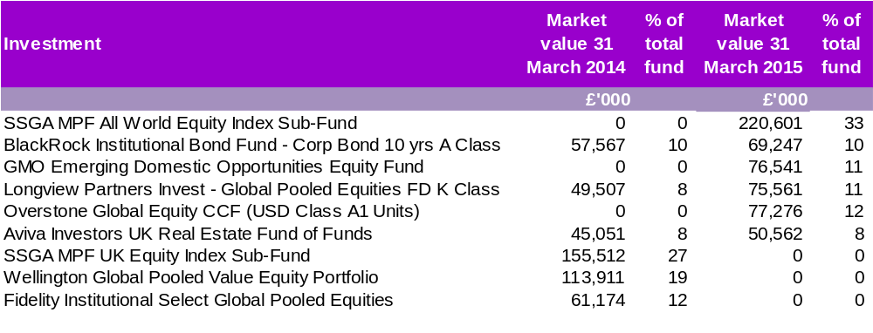
NOTE 13C: STOCK LENDING

Stock lending is permitted within pooled funds. At present, use of this facility is restricted to the State Street Global Advisors mandate.
The State Street lending programme covers equity and fixed income assets around the world and is designed to generate incremental returns for investors in a risk controlled manner.
The programme benefits from a counterparty default indemnity from State Street Bank & Trust Company pursuant to its Securities Lending Authorisation Agreement.

NOTE 14: FINANCIAL INSTRUMENTS
NOTE 14A: CLASSIFICATION OF FINANCIAL INSTRUMENTS

Accounting policies describe how different asset classes of financial instruments are measured, and how income and expenses, including fair value gains and losses, are recognised. The following table analyses the carrying amounts of financial assets and liabilities (excluding cash) by category and net assets statement heading. No financial assets were reclassified during the accounting period.

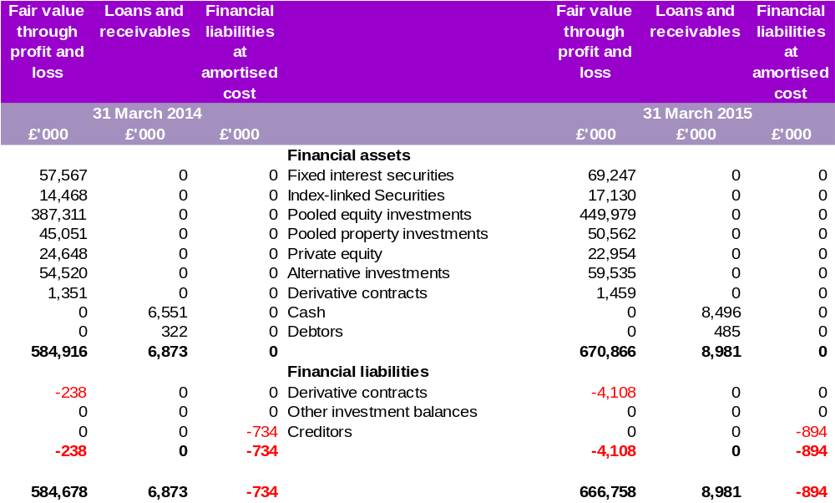

NOTE 14B: NET GAINS AND LOSSES ON FINANCIAL INSTRUMENTS

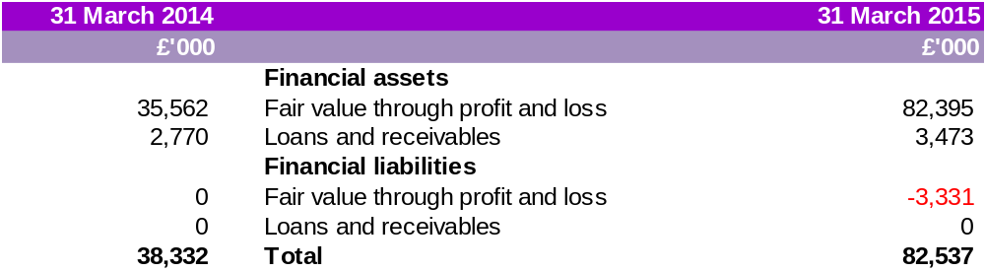

NOTE 14C: FAIR VALUE OF FINANCIAL INSTRUMENTS AND LIABILITIES

The following table summarises the carrying values of the financial assets and financial liabilities by class of instrument compared with their fair values.

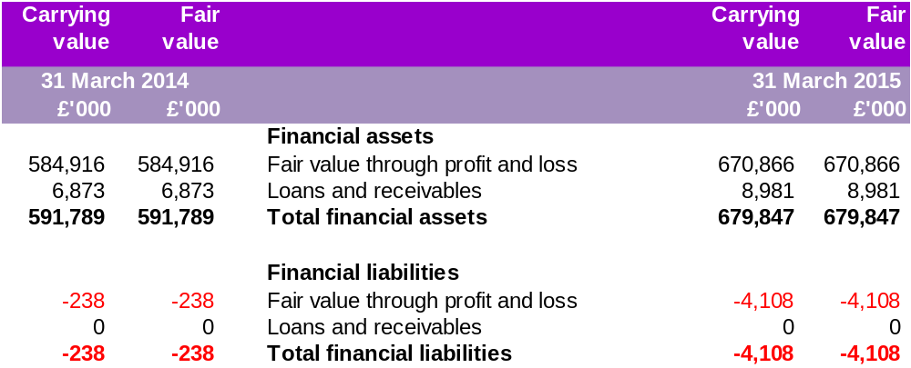
The authority has not entered into any financial guarantees that are required to be accounted for as financial instruments.

NOTE 14D: VALUATION OF FINANCIAL INSTRUMENTS CARRIED AT FAIR VALUE

The valuation of financial instruments has been classified into three levels, according to the quality and reliability of information used to determine fair values.
Level 1
Financial instruments at Level 1 are those where the fair values are derived from unadjusted quoted prices in active markets for identical assets or liabilities. Products classified as Level 1 comprise quoted equities, quoted fixed securities, quoted index linked securities and unit trusts.
Listed investments are shown at bid prices. The bid value of the investment is based on the bid market quotation of the relevant stock exchange.
Level 2
Financial instruments at Level 2 are those where quoted market prices are not available; for example, where an instrument is traded in a market that is not considered to be active, or where valuation techniques are used to determine fair value and where these techniques use inputs that are based significantly on observable market data.
Level 3
Financial instruments at Level 3 are those where at least one input that could have a significant effect on the instrument’s valuation is not based on observable market data.
Such instruments would include unquoted equity investments and hedge fund of funds, which are valued using various valuation techniques that require significant judgement in determining appropriate assumptions.
The values of the investment in private equity are based on valuations provided by the general partners to the private equity funds in which Harrow Pension Fund has invested.
These valuations are prepared in accordance with the International Private Equity and Venture Capital Valuation Guidelines, which follow the valuation principles of IFRS and US GAAP. Valuations are usually undertaken annually at the end of December. Cash flow adjustments and currency movements are used to roll forward the valuations to 31 March as appropriate.

The following tables provide an analysis of the financial assets and liabilities of the Fund grouped into Levels 1 to 3, based on the level at which the fair value is observable.

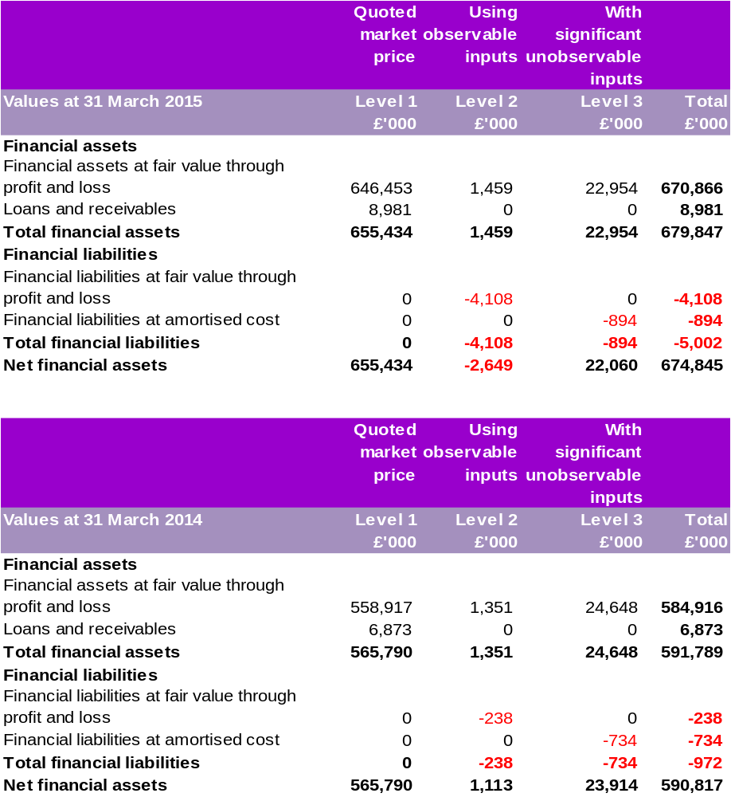

NOTE 15: NATURE AND EXTENT OF RISKS ARISING FROM FINANCIAL INSTRUMENTS

Risk and risk management

The Fund’s primary long-term risk is that its assets will fall short of its liabilities (i.e. promised benefits payable to members). Therefore the aim of investment risk management is to minimise the risk of an overall reduction in the value of the Fund and to maximise the opportunity for gains across the whole Fund portfolio. The Fund achieves this through asset diversification to reduce exposure to market risk (price risk, currency risk and interest rate risk) and credit risk to an acceptable level. In addition, the Fund manages its liquidity risk to ensure there is sufficient liquidity to meet its forecast cash flows. The Council manages these investment risks as part of its overall Pension Fund risk management programme.
Responsibility for the Fund’s risk management strategy rests with the Pension Fund Committee.

a) Market risk
Market risk is the risk of loss from fluctuations in equity and commodity prices, interest and foreign exchange rates and credit spreads. The Fund is exposed to market risk from its investment activities, particularly through its equity holdings. The level of risk exposure depends on market conditions, expectations of future price and yield movements and the asset mix.
The objective of the Fund’s risk management strategy is to identify, manage and control market risk exposure within acceptable parameters, whilst optimising the return on risk.
In general, excessive volatility in market risk is managed through the diversification of the portfolio in terms of geographical and industry sectors and individual securities. To mitigate market risk, the Council and its investment advisors undertake appropriate monitoring of market conditions and benchmark analysis.

i) Other price risk
Other price risk represents the risk that the value of a financial instrument will fluctuate as a result of changes in market prices (other than those arising from interest rate risk or foreign exchange risk), whether those changes are caused by factors specific to the individual instrument or its issuer or factors affecting all such instruments in the market.
The Fund’s investment managers mitigate this price risk through diversification.

ii) Other price risk – sensitivity analysis
Following analysis of historical data and expected investment return movement during the financial year, in consultation with the Fund’s performance advisors, the Council has determined that the following movements in market price risk are reasonably possible for the 2015/16 reporting period:

Assets type | Potential market movements (+/-)
Total equities | 9.01%
Fixed interest & index linked securities | 8.49%
Alternative investments | 6.92%
Cash and equivalents | 0.01%
Pooled property investments | 2.60%

Potential price changes are determined based on the observed historical volatility of asset class returns. ‘Riskier’ assets such as equities will display greater potential volatility than bonds as an example, so the overall outcome will depend largely on the Fund’s asset allocations. The potential volatilities are consistent with a one standard deviation movement in the change in value of the assets over the latest three years. This can then be applied to the period end asset mix.
Had the market price of the Fund investments increased/decreased in line with the above the change in the net assets available to pay benefits would have been as follows:

Asset type | Value as at 31 March 2015 | Percentage change | Value on increase | Value on decrease
 | £'000 | % | £'000 | £'000
Cash and cash equivalents | 6,930 | 0.01 | 6,931 | 6,929
Investment portfolio assets:
Total equities | 472,933 | 9.01 | 515,544 | 430,322
Fixed interest & index linked securities | 86,377 | 8.49 | 93,710 | 79,044
Alternative investments | 59,535 | 6.92 | 63,655 | 55,415
Pooled property investments | 50,562 | 2.60 | 51,877 | 49,247
Derivative contracts: net forward currency | -2,649 | 0.00 | -2,649 | -2,649
Total | 673,688 |  | 729,068 | 618,308

- Interest rate risk
The Fund invests in financial assets for the primary purpose of obtaining a return on investments. These investments are subject to interest rate risks, which represent the risk that the fair value or future cash flows of a financial instrument will fluctuate because of changes in market interest rates.
The Fund’s direct exposure to interest rate movements as at 31 March 2015 and 31 March 2014 is set out below.

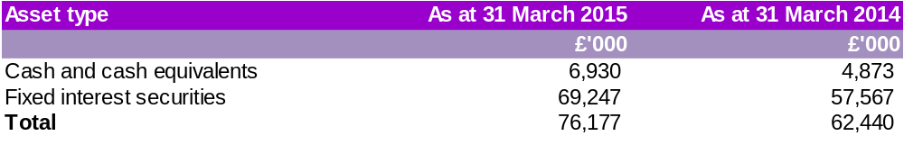
Interest rate risk sensitivity analysis
The Council recognises that interest rates can vary and can affect both income to the Fund and the carrying value of Fund assets, both of which affect the value of the net assets available to pay benefits.
The impact of a 1% movement in interest rates would be as follows:

Asset type | Carrying amount as at 31 March 2015 |  | Effect on asset value
 |  | +1% | -1%
 | £'000 | £'000 | £'000
Cash and cash equivalents | 6,930 | 0 | 0
Fixed interest securities | 69,247 | -692 | 692
Total change in assets available | 76,177 | -692 | 692
Asset type | Carrying amount as at 31 March 2014 |  | Effect on asset value
 |  | +1% | -1%
 | £'000 | £'000 | £'000
Cash and cash equivalents | 4,873 | 0 | 0
Fixed interest securities | 57,567 | -576 | 576
Total change in assets available | 62,440 | -576 | 576

This analysis demonstrates that changes in interest rates do not impact on the value of cash & cash equivalents balances but do affect the fair value on fixed interest securities.
Changes in interest rates affect interest income received on cash balances but have no effect on income from fixed income securities. However since the Fund’s cash balances are low, the effect of interest changes is minimal.
c) Currency risk
Currency risk represents the risk that the fair value of future cash flows of a financial instrument will fluctuate because of changes in foreign exchange rates. The fund is exposed to currency risk on its global equities pooled fund investments, some of which are denominated in currencies other than sterling. To mitigate this risk, the Fund uses derivatives and hedges 50% of the overseas equity portfolio arising from the developed market currencies.
The table below provides the estimated total of the Fund’s currency exposure as at 31 March 2015.
Following analysis of historical data in consultation with the Fund’s performance advisors the Council considers the likely volatility associated with foreign exchange rate movements to be 3.62%
This fluctuation is based on the advisors analysis of long term historical movements in the month end exchange rates over a rolling 3 years’ period.
A 3.62% strengthening/weakening of the pound against the various currencies in which the fund holds investments would increase/decrease the net assets available as follows.

Currency Exposure - asset type | Asset Value as at 31 March 2015 | Change to net assets
 |  | +3.62% | -3.62%
 | £'000 | £'000 | £'000
Overseas Equities | 398,206 | 412,621 | 383,791

d) Credit risk
Credit risk represents the risk that the counterparty to a transaction or a financial instrument will fail to discharge an obligation and cause the Fund to incur a financial loss. The market values of investments generally reflect an assessment of credit in their pricing and consequently the risk of loss is implicitly provided for in the carrying value of the Fund’s assets and liabilities.
In essence the Fund’s entire investment portfolio is exposed to some form of credit risk, with the exception of the derivatives positions. However the selection of high quality counterparties, brokers and financial institutions by Fund managers should minimise the credit risk that may occur.
Cash deposits are not made with banks and financial institutions unless they are rated independently and meet the Council’s credit criteria.
The Council believes it has managed its exposure to credit risk, and has had no experience of default or uncollectable deposits over the past five years.

The Fund’s cash holding at 31 March 2015 was £6.9m (31 March 2014: £4.9m). This was held with the following institutions.

Summary | Balances at 31 March 2015 | Balances as 31 March 2014
 | £'000 | £'000
Bank accounts
Royal Bank of Scotland | 4,633 | 530
JP Morgan | 1,432 | 3,741
BlackRock | 865 | 602
 | 6,930 | 4,873

e) Liquidity risk
Liquidity risk represents the risk that the Fund will not be able to meet its financial obligations as they fall due. The Council therefore takes steps to ensure that the Pension Fund has adequate cash resources to meet its commitments.
The Council has immediate access to its Pension Fund cash holdings.
The Fund considers liquid assets to be those that can be converted to cash within three months. Illiquid assets are those assets which will take longer than three months to convert in to cash. As at 31 March 2015 the value of illiquid assets was £73.5m, which represented 11% of the total Fund assets (31 March 2014: £69.7m, which represented 12% of the total Fund assets).
All financial liabilities at 31 March 2015 are due within one year.
f) Refinancing risk
The Pension Fund does not have any financial instruments that have a refinancing risk.
NOTE 16: FUNDING ARRANGEMENTS
In line with The Local Government Pension Scheme Regulations 2013, the Fund’s actuary undertakes a Funding valuation every three years for the purpose of setting employer contribution rates for the forthcoming triennial period. The last such valuation took place as at 31 March 2013. The next valuation will take place as at 31 March 2016.
The key elements of the Funding policy are:
- to ensure the long-term solvency of the Fund, i.e. that sufficient funds are available to meet all pension liabilities as they fall due for payment;
- to ensure that employer contribution rates are as stable as possible;
- to minimise the long-term cost of the Scheme by recognising the link between assets and liabilities and adopting an investment strategy that balances risk and return;
- to reflect the different characteristics of employing bodies in determining contribution rates where the administering authority considers it reasonable to do so; and
- To use reasonable measures to reduce the risk to other employers and ultimately to the Council Tax payer from an employer defaulting on its pension obligations.
The aim is to achieve 100% solvency over a period of 20 years and to provide stability in employer contribution rates by spreading any increases in rates over a period of time. Normally this is three years but in some cases a maximum period of 12 years can be granted. Solvency is achieved when the funds held, plus future expected investment returns and future contributions, are sufficient to meet expected future pension benefits payable.
At the 2013 actuarial valuation, the Fund was assessed as 70.3% funded (73.5% at the March 2010 valuation). This corresponded to a deficit of £234m (2010 valuation: £157m) at that time.
For most employers within the Fund, contribution increases were phased in over the 3 years’ period ending 31 March 2017.
Individual employers’ rates vary depending on the demographic and actuarial factors particular to each employer. Full details of the contribution rates payable can be found in the 2013 actuarial valuation report on the Fund’s website.
The valuation of the Fund has been undertaken using the projected unit method under which the salary increase for each member is assumed to increase until they leave active service by death, retirement or withdrawal from service. The principal assumptions were as follows:

Financial assumptions

Price inflation (CPI) 2.5%
Salary increases 3.8%
Pension increases 2.5%
Gilt based discount rate 3.0%
Funded basis discount rate 4.6%

Mortality assumptions

The life expectancy assumptions are based on the Fund’s Hymans Robertson’s VitaCurves with improvements in line with the CMI 2010 model, assuming the current rate of improvements has reached a peak and will converge to a long term rate of 1.25% per annum.

Future life expectancy based on the actuary’s Fund-specific mortality review was as follows.



Commutation assumption

It is assumed that 50% of future retirees will elect to exchange pension for additional tax free cash up to HMRC limits for service to 1 April 2008 and 75% for service from 1 April 2008.

NOTE 17: ACTUARIAL PRESENT VALUE OF PROMISED RETIREMENT BENEFITS
In addition to the triennial funding valuation, the Fund’s actuary also undertakes a valuation of the Pension Fund liabilities, on an IAS 19 basis, every year using the same base data as the funding valuation rolled forward to the current financial year, taking account of changes in membership numbers and updating assumptions to the current year. This valuation is not carried out on the same basis as that used for setting Fund contribution rates and the Fund accounts do not take account of liabilities to pay pensions and other benefits in the future.
In order to assess the value of the benefits on this basis, the actuary has updated the actuarial assumptions (set out below) from those used for funding purposes (see Note 16). The actuary has also valued ill health and death benefits in line with IAS 19.
Calculated on an IAS 19 basis, the actuarial present value of promised retirement benefits at 31 March 2015 was £959m (31 March 2014: £824m). The net assets available to pay benefits as at 31 March 2015 was £602m (31 March 2014: £528m). The implied Fund deficit as at 31 March 2015 was therefore £357m (31 March 2014: £296m).
As noted above, the liabilities above are calculated on an IAS 19 basis and therefore will differ from the results of the 2013 triennial funding valuation because IAS 19 stipulates a discount rate rather than a rate which reflects market rates.

Assumptions used

Inflation/pension increase rate assumption |  | 2.4%
Salary increase rate |  | 3.8%
Discount rate |  | 3.2%
NOTE 18: CURRENT ASSETS

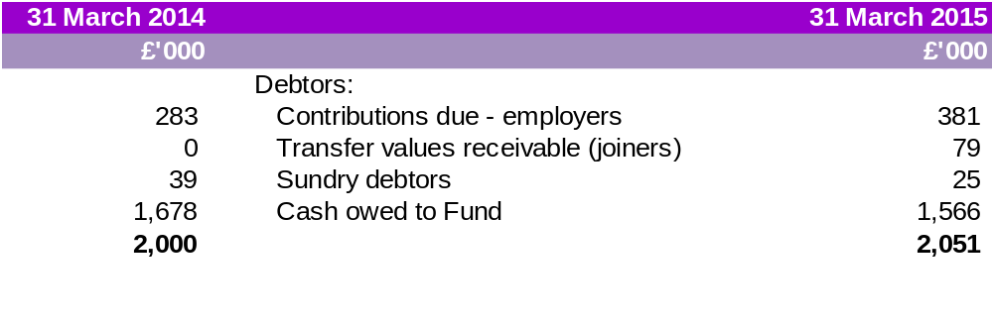
Analysis of debtors
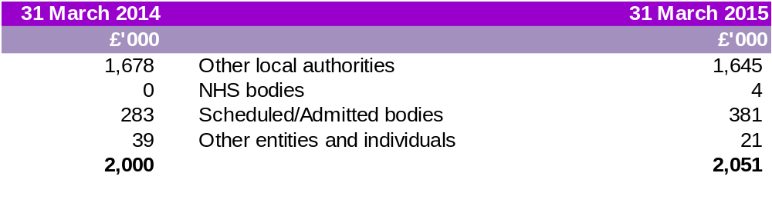
NOTE 19: CURRENT LIABILITIES

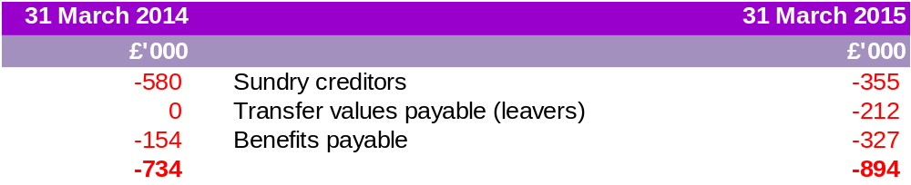
Analysis of creditors
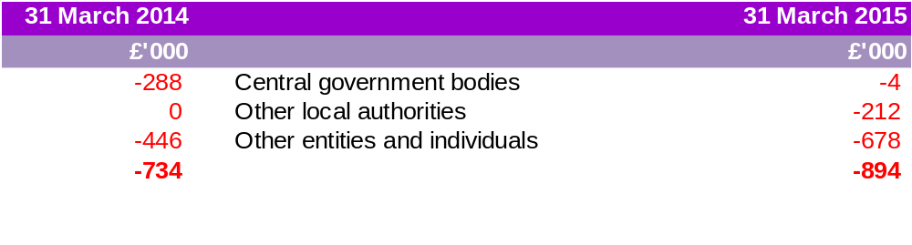
NOTE 20: ADDITIONAL VOLUNTARY CONTRIBUTIONS

The Fund provides an additional voluntary contributions (AVC) Scheme for its members, the assets of which are invested separately from those of the Fund. The Fund has appointed Prudential, Clerical Medical and Equitable Life as its AVC providers. AVCs are paid to the AVC provider by employees and are specifically for providing additional benefits for individual contributors. Each AVC contributor receives an annual statement showing the amount held in their account and the movements in the year.

AVCs are not included in the accounts in accordance with section 4(2)(b) of The Local Government Pension Scheme (Management and Investment of Funds) Regulations 2009 (SI 2009/3093) but are disclosed as a note only.

AVC contributions of £0.36m were paid directly to the providers during the year (2013/14: £0.37m)

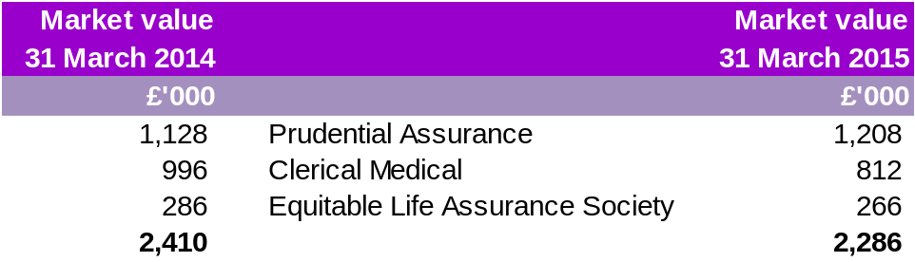

NOTE 21: RELATED PARTY TRANSACTIONS

Harrow Council
The Fund is required under IAS24 to disclose details of material transactions with related parties. The Council is a related party to the Pension Fund. Details of the contributions made to the Fund by the Council and expenses refunded to the Council are set out above.
The Pension Fund has operated a separate bank account since April 2011. However, due to the ease of administration and to avoid any undue cost to the Fund some transactions continue to be processed through the Council’s bank account and as such these balances are settled on a monthly basis.

31 March 2014 |  | 31 March 2015
£'000 |  | £'000
-15,042 | Employer's Pension Contributions to the Fund | -16,162
787 | Administration expenses paid to the Council | 1,061
1,678 | Cash held by the Council | 1,566

Governance
Each member of the Pension Fund Committee is required to declare their interests at each meeting.
Key management personnel
Paragraph 3.9.4.3 of the Code exempts local authorities from the key management personnel disclosure requirements of IAS 24, on the basis that the disclosure requirements for officer remuneration and members’ allowances detailed in section 3.4 of the Code (which are derived from the requirements of Regulation 7(2)–(4) of The Accounts and Audit (England) Regulations 2011 and Regulation 7A of The Accounts and Audit (Wales) Regulations 2005) satisfy the key management personnel disclosure requirements of paragraph 16 of IAS 24. This applies in equal measure to the accounts of the Harrow Pension Fund.
The disclosures required by Regulation 7(2)–(4) of The Accounts and Audit (England) Regulations can be found in the main accounts of Harrow Council.

NOTE 22: CONTINGENT LIABILITIES AND CONTRACTUAL COMMITMENTS
Outstanding capital commitments at 31 March 2015 totalled £4.5m (31 March 2014: £5.1m).
These commitments relate to outstanding call payments due on unquoted limited partnership Funds held by Pantheon Ventures in the private equity part of the portfolio.
NOTE 23: CONTINGENT ASSETS
Six admitted body employers in the Fund hold insurance bonds or guarantees to guard against the possibility of being unable to meet their pension obligations. These bonds are drawn in favour of the Fund and payment will only be triggered in the event of employer default.



